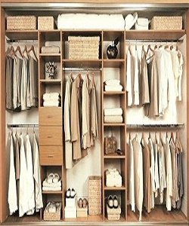

Modern Wardrobe

$163.39

Availability: In stock

**Description:**

Sliding door wood wardrobe with many sections. this room divider can be used to define space in an open concept room, or can be set in front of a large window for privacy. Rounding out the design, metal hinges make folding and storage a breeze when not in use.